  **D.A.V PUBLIC SCHOOL**

**DANI BIGHA, AURANAGABAD**

__________________________________________________________________________________

**SUMMER VACATION HOMEWORK**

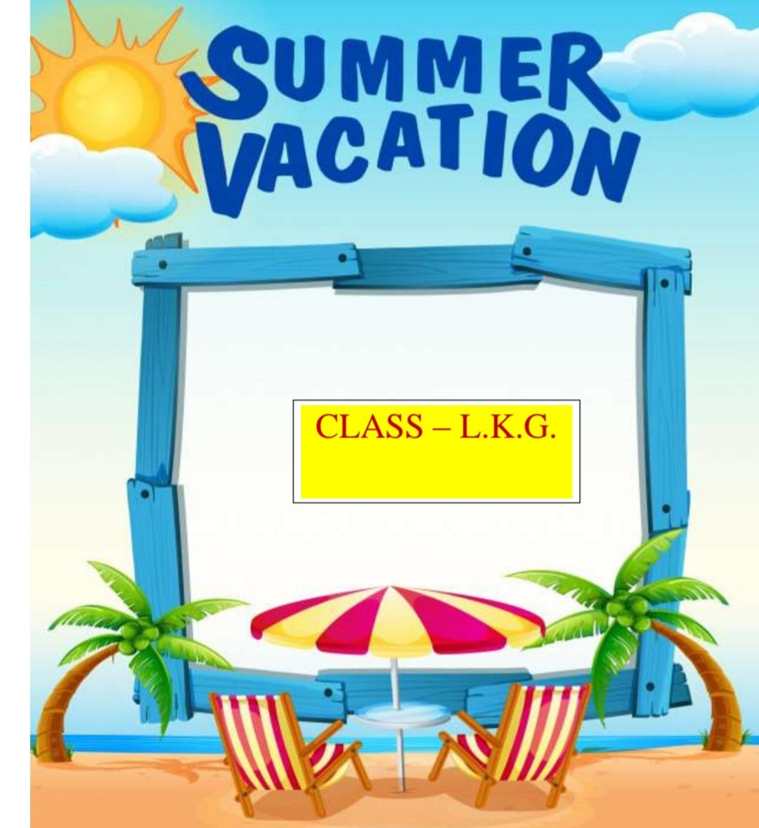

**English:**

**Oral work:-**

**Learn About Myself**

**Learn 5 fruits name (with spelling)**

**Learn 5 vegetables name (with spelling)**

**Read “a”and “b”sound story**

**Maths:**

**Oral work:-**

**Learn counting 1 to 50**

**Learn shapes name (with spelling)**

**Learn colours name (with spelling)**

**हिन्दी:**

**मौखिक कार्य:**

**स्वर अक्षर याद करें ( अ से अ: तक)**

**व्यंजन वर्ण याद करें (क से ज्ञ तक)**

**मेरा परिचय याद करें।**

**Rhymes:**

**Bits of paper**

**Father up above**

**My dear ones**

**कबूतर**

**मोर**

**कौआ**

**तोता**

***Make a video of rhymes (with action)***

***and Send it on class group.***

**Project:**

* **Prepare a alphabet chart (A to Z)**

**with Picture on chart paper .**

* **Prepare a model of big and small**

**object and Tall and Short object.**

* **पंछियों के चित्र चार्ट पेपर पर चिपकाएं तथा**

**नाम लिखें।**

**Worksheet :**

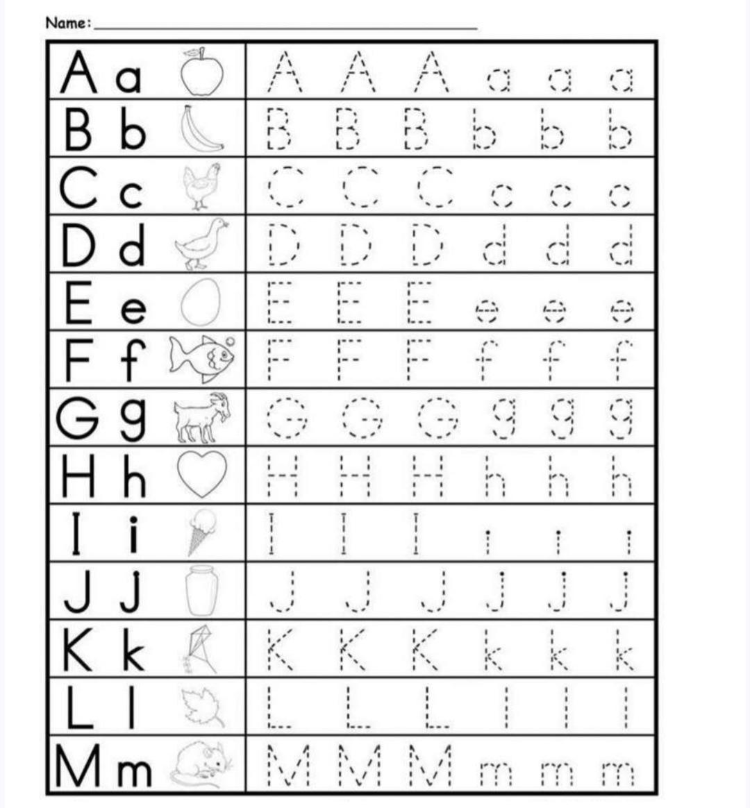

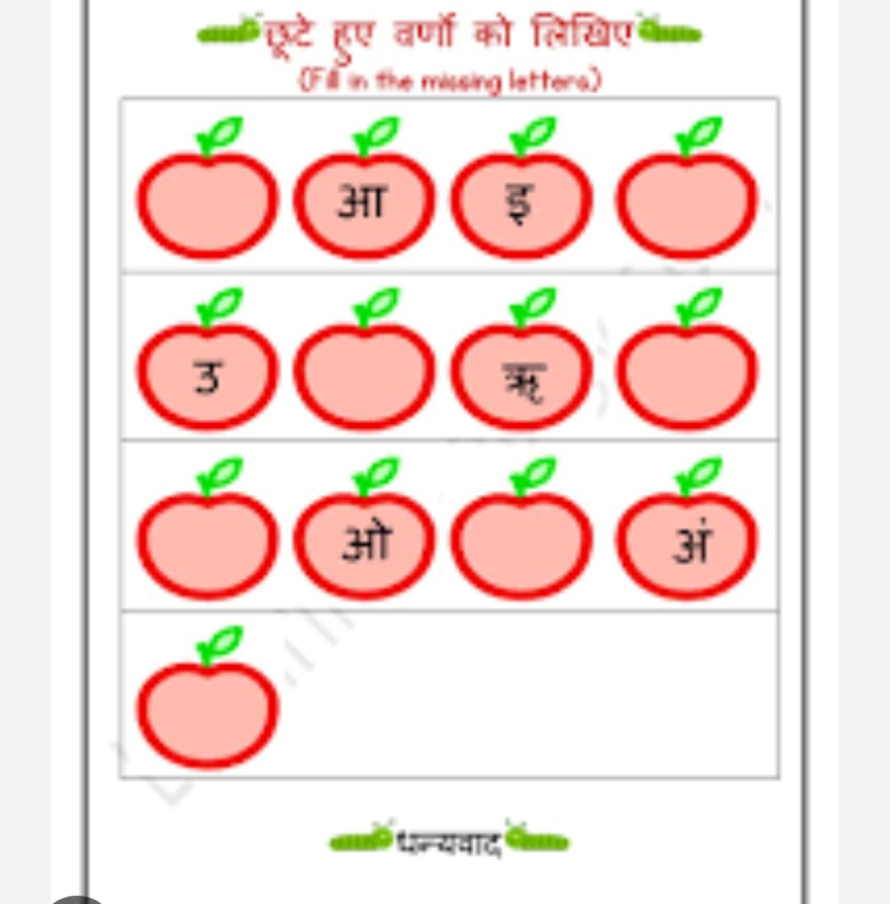

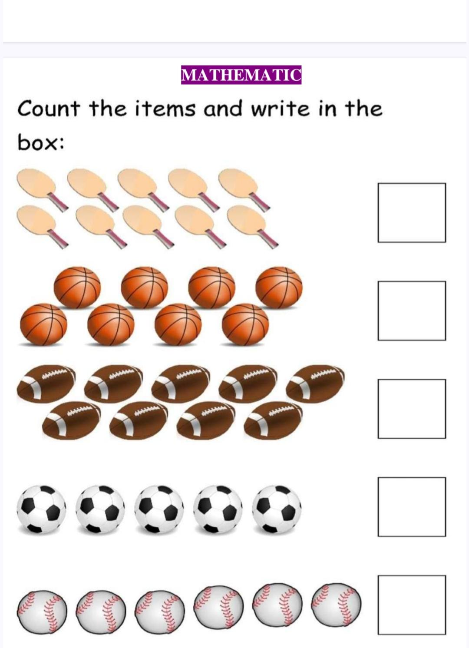

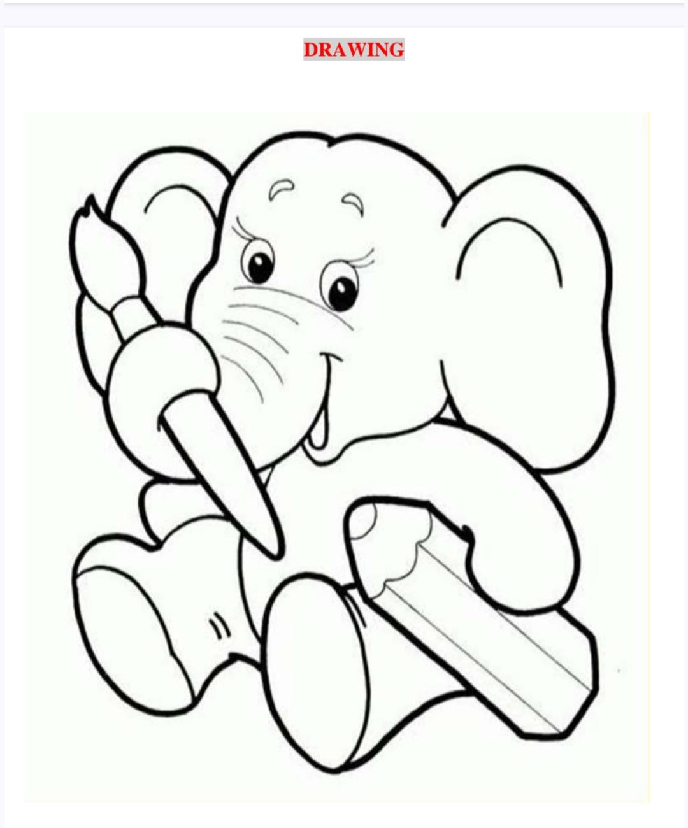

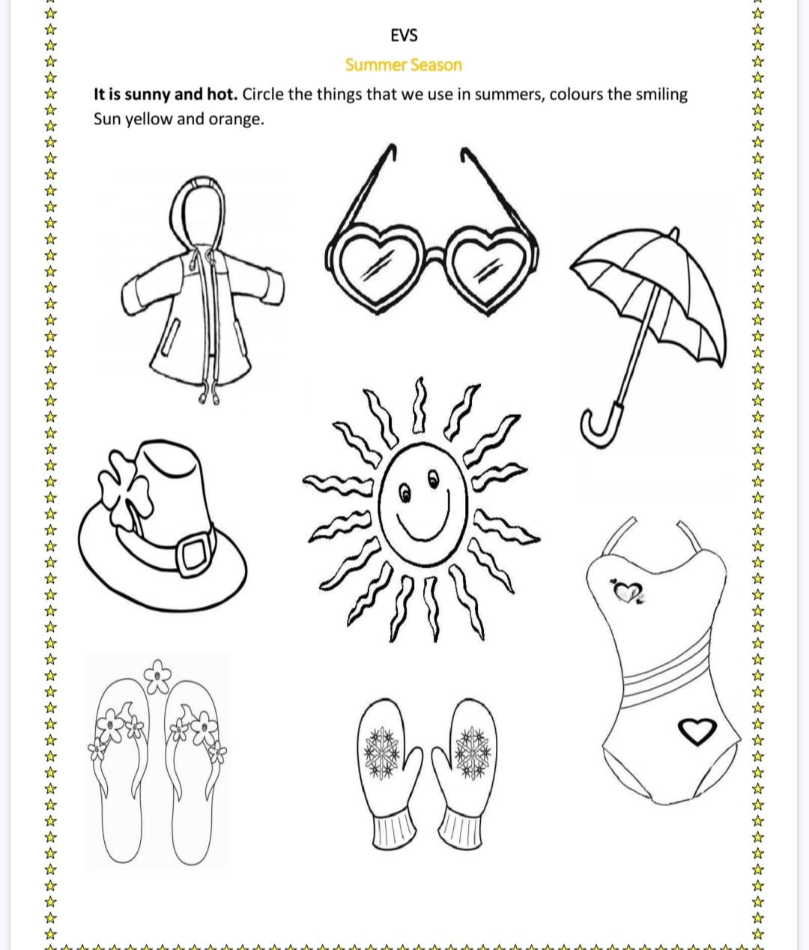

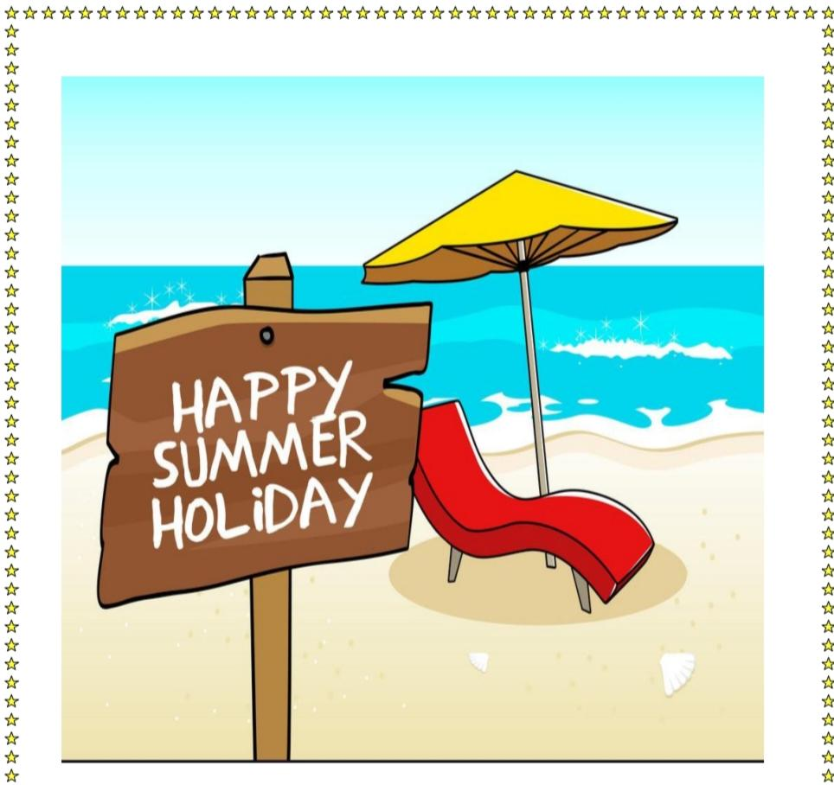

***Have a wonderful vacation***

***Be safe and Healthy***

**Thank you**

**Class Teacher**

**LKG**